**Schedule of Implementation of Community Service Proposal Clinic Activities for 2021**

By: **Cindra Zakaria**. May 21, 2021. 10:00:09

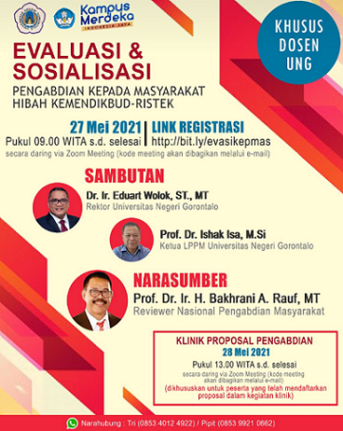

EVALUATION &

SOCIALIZATION

DEVOTED FOR UNG LECTURERS

Community Services Grants of the Ministry of Education, Culture, Research and Technology

May 27, 2021

At 09.00 WITA until finished

Registration Link

<http://bit.ly/evasikepmas>

online through zoom meeting (meeting code will be shared through email)

WELCOMING

Dr. Ir. Eduart Wolok, S.T., MT

Rector of Universitas Negeri Gorontalo

Prof. Dr. Ishak Isa, M.Si

Head of LPPM Universitas Negeri Gorontalo

SPEAKER

Prof. Dr. Ir. H. Bakhrani A. Rauf, MT

National Community Service Reviewer

Service Proposal Clinic

May 28, 2021

At 13.00 WITA until finished

online through zoom meeting (meeting code will be shared through email)

(Devoted to participants who have registered their proposals for the clinical program)

Contact Person: Tri (0853 4012 4922)/ Pipit (0853 9921 0662)